AI ASSISTED CODING: 13.4

NAME:M.VARSHITHA

ROLLNO:2403A52342

Task1:

refactor loops in legacy python code into cleaner pythonic version using list comprehensions while giveing the output same

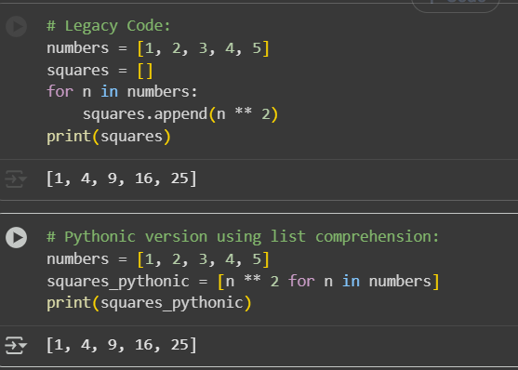

Task2:

Simplify string concatenation, Review the loop that builds a sentence using +=, Refactor using " ".join() to improve efficiency and readability.

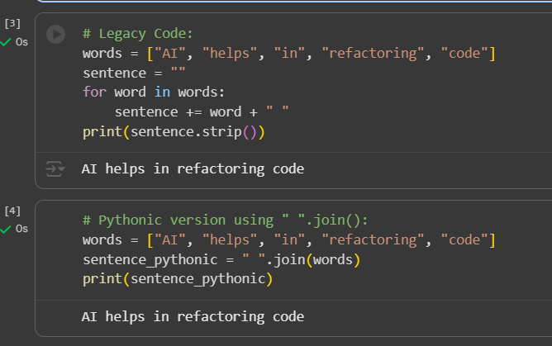

Task3:

Replace manual dictionary lookup with a safer method

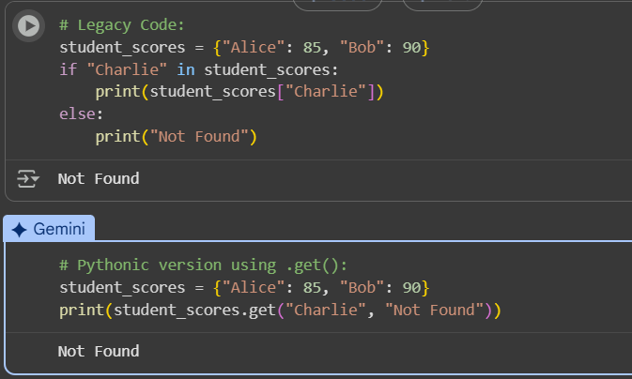

Task4: Refactor repetitive if-else blocks

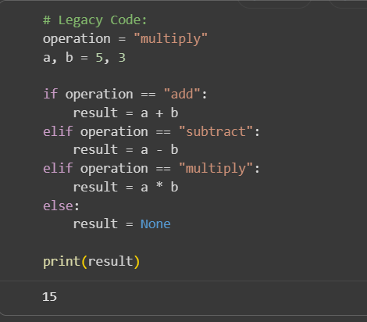

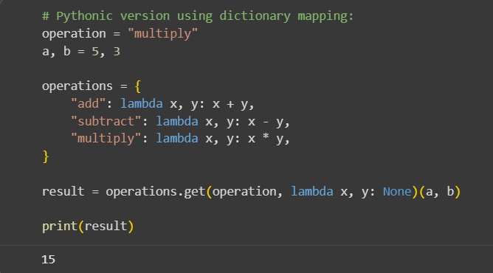

Task5: Optimize nested loops for searching

